**Lab Exercise Date 31-01-2019**

1. Write a C-program for performing the basic 2D translation of a line (5, 8) and (12, 18) by a factor of (2,1).
2. Write a C-program for performing the basic 2D transformations like scaling and shearing by a factor of (2, 2) on an object with following co-ordinates

(100,100), (200,100), (200, 200), (100, 200).

1. Write a C-program for performing the basic 2D rotation of the triangle with following co-ordinates about the point (50, 50) by an angle -45 degree.

(100,100), (100, 200) and (200, 200)

1. Write a C-program for performing the basic 2D reflection of the above triangle about x-axis, y-axis and y=x line.
2. Write a C program for Scaling, Rotation and Shear using Affine transformation (Homogeneous Co-ordinates) on the following objects:

* Triangle
* Square/Rectangle

**Instructions**

**Translation**

A translation process moves every point a constant distance in a specified direction. It can be described as a rigid motion. A translation can also be interpreted as the addition of a constant vector to every point, or as shifting the origin of the coordinate system.  
Suppose, If point (X, Y) is to be translated by amount Dx and Dy to a new location (X’, Y’) then new coordinates can be obtained by adding Dx to X and Dy to Y as

X’ = X + Dx;

Y’ = Y + Dy

**Scaling**

A scaling transformation alters size of an object. In the scaling process, we either compress or expand the dimension of the object.  
Scaling operation can be achieved by multiplying each vertex coordinate (X, Y) of the polygon by scaling factor Sx and Sy to produce the transformed coordinates as (X’, Y’). So,

X’ = X *Sx

Y’ = Y * Sy.

**Shearing**

Shear is the translation along an axis by an amount that increases linearly with another axis . Shear transformation changes the shape of the object to a slant position.

**Shear transformation is of 2 types:**

1. X-shear: changing x-coordinate value and keeping y constant

X’ = X + shx*Y

Y’ = Y

1. Y-shear: changing y coordinates value and keeping x constant

X’ = X

Y’ = X*shy + Y

**Rotation**

We have to rotate an object by a given angle about a given pivot point and print the new co-ordinates. In order to rotate an object we need to rotate each vertex of the figure individually.  
On rotating a point P(X, Y) by an angle A about the origin we get a point P'(X’, Y’). The values of X’ and Y’ can be calculated as follows

X’ = X cosA – Y sinA

Y’ = X sinA + Y cosA

**Reflection**

Reflection is nothing but producing mirror image of an object. Reflection can be done just by rotating the object about a given axis of reflection with an angle of 180 degrees.

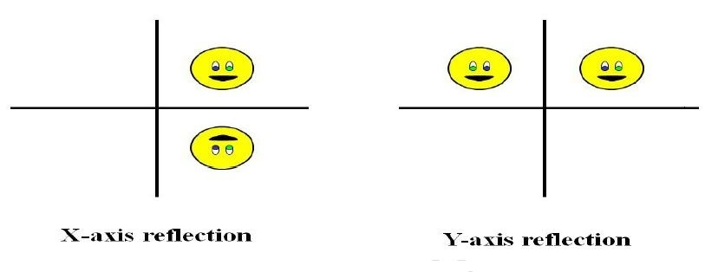

To reflect a point (X, Y) about y-axis

X’ = -X

Y’ = Y

To reflect a point (X, Y) about x-axis

X’ = X

Y’ = -Y

To reflect a point about Y=X line

X’ = Y

Y’ = X

**Note: 1. For affine transform follow the pdf attached**

**2. For drawing line use the in-built graphics function**

**line(x1, y1, x2, y2)**